**Hallvard Moan Kristiansen og David Kvasnes Olsen**

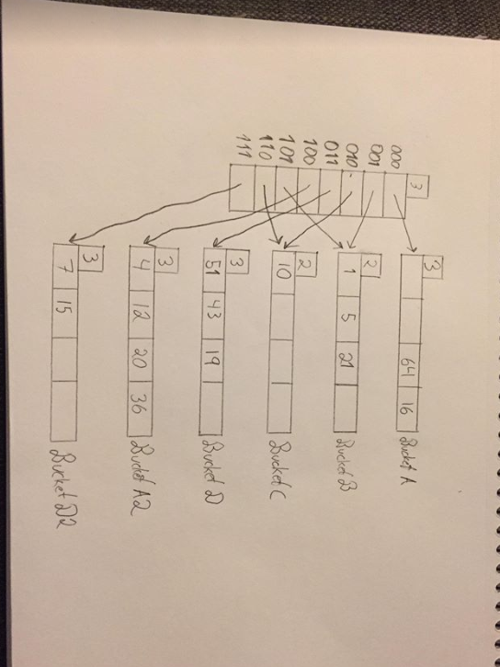

**2.1   
N should be increased, because one new bucket is added when r/n*bfr > 0.8.   
And it is currently 0.83. (5/(3*2)).**

**The state of the system is n=4.**

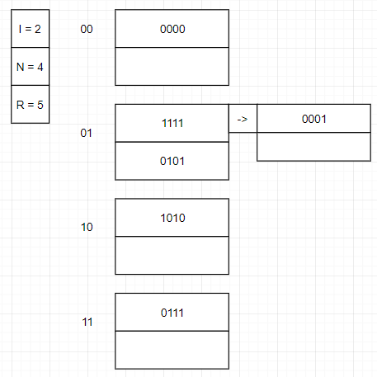

**N=5**

